Output for er diagram

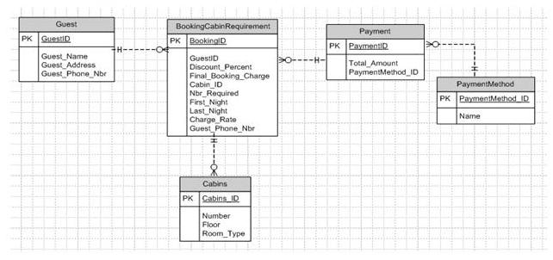
- Guest ( GuestID, Guest_Name, Guest_Address, Guest_Phone_Nbr )
- BookingCabinRequirement ( BookingID, GuestID, Discount_Percent, Final_Booking_Charge, Cabin_ID, Nbr_Required, First_Night, Last_Night, Charge_Rate, Guest_Phone_Nbr ) foreign key (GuestID) references Guest(GuestID)
foreign key (Cabin_ID) references Cabins(Cabin_ID )
- Cabins (Cabins_ID, Number, Floor, Room_Type)
- Payment( PaymentID, Total_Amount, PaymentMethod_ID)
foreign key (PaymentMethod_ID ) references PaymentMethod ( PaymentMethod_ID )
- PaymentMethod ( PaymentMethod_ID, Name)

